Home Care Cost Report Preparation Policies and Procedures

<insert name of agency>
For calendar year <insert calendar year>
Prepared by < insert name and title of the preparer of document>
As of <insert date the document was created>
Table of Contents
Background 1
Preparation of the Home Care Cost Report 1
Completing the Reporting Hierarchy tab 5
Completing the Cost Report Schedules tab 5
Completing the General Questionnaire tab 10
Cost Report Submission 11
Uploading Supporting Documentation 11
Agency Representation 13
Questions 13

Background
In accordance with Public Health Law (PBH) §3612(8) and Social Services (SOS) Law §365-f (4-a), the commissioner may require a health home or licensed home care services agency, or a fiscal intermediary to report on the costs incurred by the agency in rendering health care services to Medicaid beneficiaries and the New York State Department of Health (DOH) may specify the frequency and format of such reports. DOH requires all Certified Home Health Agencies (CHHA), Licensed Home Care Services Agencies (LHCSA), and Fiscal Intermediaries (Fl) operating in New York State to submit the Home Care Cost Report to DOH on an annual basis.
The Home Care Cost Report data is used by the Department to set Medicaid reimbursement rates. This <insert calendar year being reported> cost report will produce a <insert current year> reimbursement rate.
The purpose of this document is to detail the policies and procedures related to the preparation of the Home Care Cost Report, which is required to be submitted to the New York State Department of Health annually. <Insert agency name> provides services such as, <list out home care services agency provide (e.g., PC Level I, home health aide, etc.)>. The associated entities included in this report include <list out entity types that agency operates (e.g., CHHA, LHCSA, FI)>.

Preparation of the Home Care Cost Report
This section details the information necessary to begin the cost report submission process.
Roles and responsibilities:
The following individuals are responsible for the preparation and review of the cost report:
Responsible Party/Parties | Responsibilities
<Title of individual> | Preparer of the cost report
<Title of individual> | Project Liaison
<Title of individual> | Reviewer of the cost report
<Title of individual> | Certifier and submitter of the cost report

Gathering Source Documentation:
To complete the cost report, you will need access to the source documents listed in the table below.
<Fill out the table below with the documents specific to your agency that are necessary to fill out the cost report and the party or platform that it should be requested from (e.g., Sandata, HHAexchange, or Finance department, etc.). Data sources that will likely be needed include a Trial Balance, General Ledger, P&L, statistical report, payroll report/payroll register, financial statements, invoices, FTE report, WR&R detail, etc. >
Document | How to access to this document?
Insert document name | Insert location/system or department/person
Insert document name | Insert location/system or department/person
Insert document name | Insert location/system or department/person
Insert document name | Insert location/system or department/person
Insert document name | Insert location/system or department/person
Insert document name | Insert location/system or department/person

Accessing the Web-based Tool:
The Home Care Cost Report is submitted via the Home Care Web-based Tool at the following link: https://desoto.certisphere.com/doh/HomeCareDashboard.html. Please navigate to the Home Care Tool website and follow the steps below to log in and begin completing the cost report.
- The link will bring you to the following landing page, where you can access the current and past cost reports. Select the current cost report year by clicking “Go.”
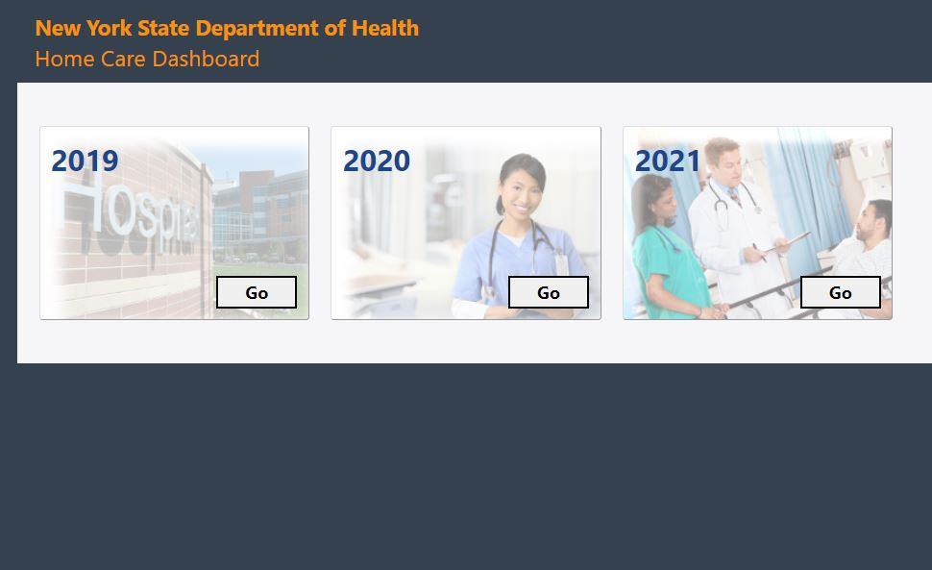
- You will then be directed to the login page, as shown in the screenshot below. Enter your username and password. If you do not already have login credentials, reach out to us-advrisknyshc@kpmg.com to request credentials and include:
- Your first and last name
- Email address
- The agency/agencies you need access to within the web-based tool
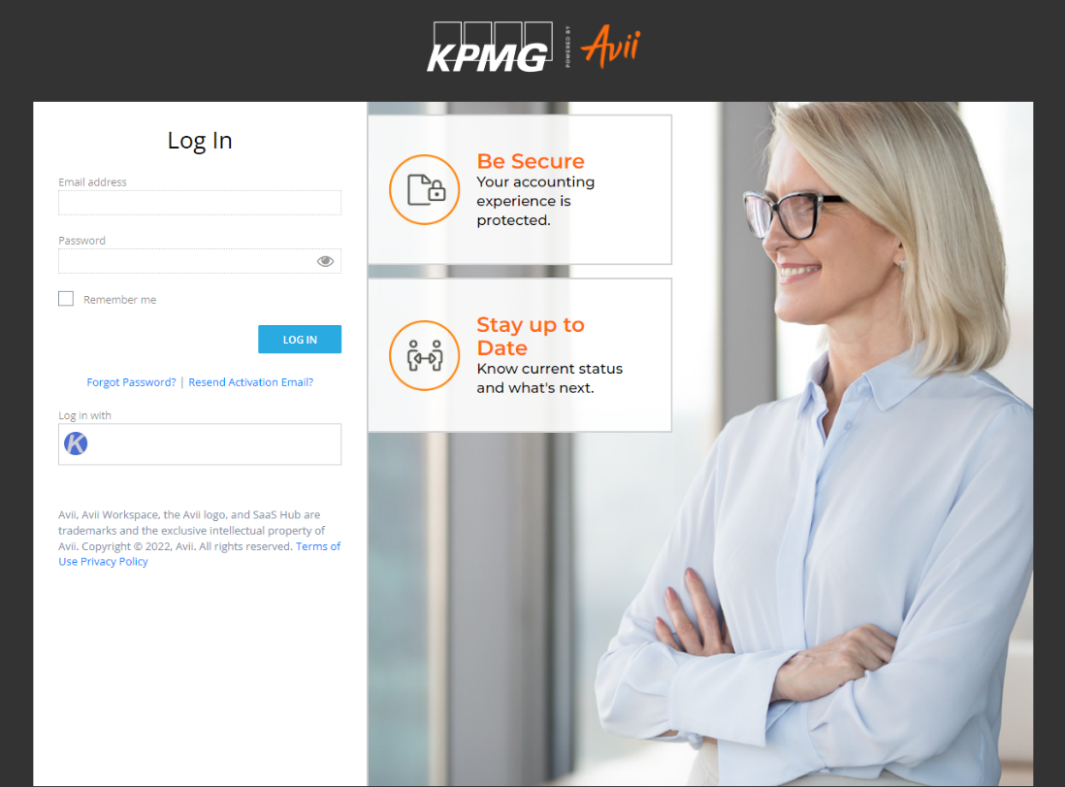
- After entering your login credentials, you will be prompted to “select an organization” from a drop-down menu. In this drop-down, select <insert agency name>. If the agency is not listed, please reach out to us-advrisknyshc@kpmg.com.
Allocation Methodologies:
Several schedules of the Home Care Cost Report may require costs to be allocated across entities and/or across the service types in each entity. This section details the allocation methodologies applied to the different cost report schedules, if applicable.
<Insert detail related to the allocation methodologies used throughout the cost report. Examples of allocation methodologies include allocating based on total operating expenses, percentage of totals hours/visits, square feet occupied, and time study.>
Examples of calculating the allocation methodologies are provided below.

Example of allocation across agency using total service hours:
Entity name | Total service hours | Allocation Percentage
<insert entity name> | 10,000 | 40%
<insert entity name> | 5,000 | 20%
<insert entity name> | 9,000 | 36%
<insert entity name> | 1,000 | 4%
Total | 25,000 | 100%

Example of allocation across service types using total service hours:
Service Type | Total service hours | Allocation Percentage
<insert service type> | 3,000 | 12%
<insert service type> | 4,000 | 16%
<insert service type> | 12,000 | 48%
<insert service type> | 6,000 | 24%
Total | 25,000 | 100%

Completing the Reporting Hierarchy tab
The first tab that must be completed within the Tool is the “Reporting hierarchy” tab. This tab collects general agency and entity information.
The entity types entered in I.3 will be used to automatically populate particular schedules of the cost report that will appear in the “Cost Report Schedules” tab. The “a” version of schedules will populate for CHHAs, the “b” version of schedules will populate for LHCSAs, and the “c” version of schedules will populate for FIs. <Insert agency name> operates <insert entity types your agency operates (e.g., CHHA, LHCSA and/or FI>, so the <insert “A” if your agency operates a CHHA, insert “b” if your agency operates a LHCSA and insert “c” if your agency operates an FI> version of the cost report schedules will appear within the cost report schedules tab. The information submitted within the Reporting Hierarchy will also be used to automatically populate the required fields in Schedule 1 (General Information –Agency) and Schedule 2 (General Information –Entity).
Once the Reporting tab is completed, select the “submit” button in the top right corner of the screen.

Completing the Cost Report Schedules tab
After the “Reporting Hierarchy” tab has been submitted, the “Cost Report Schedules” tab will be available (shown in image below). There are 19 schedules that must be completed.
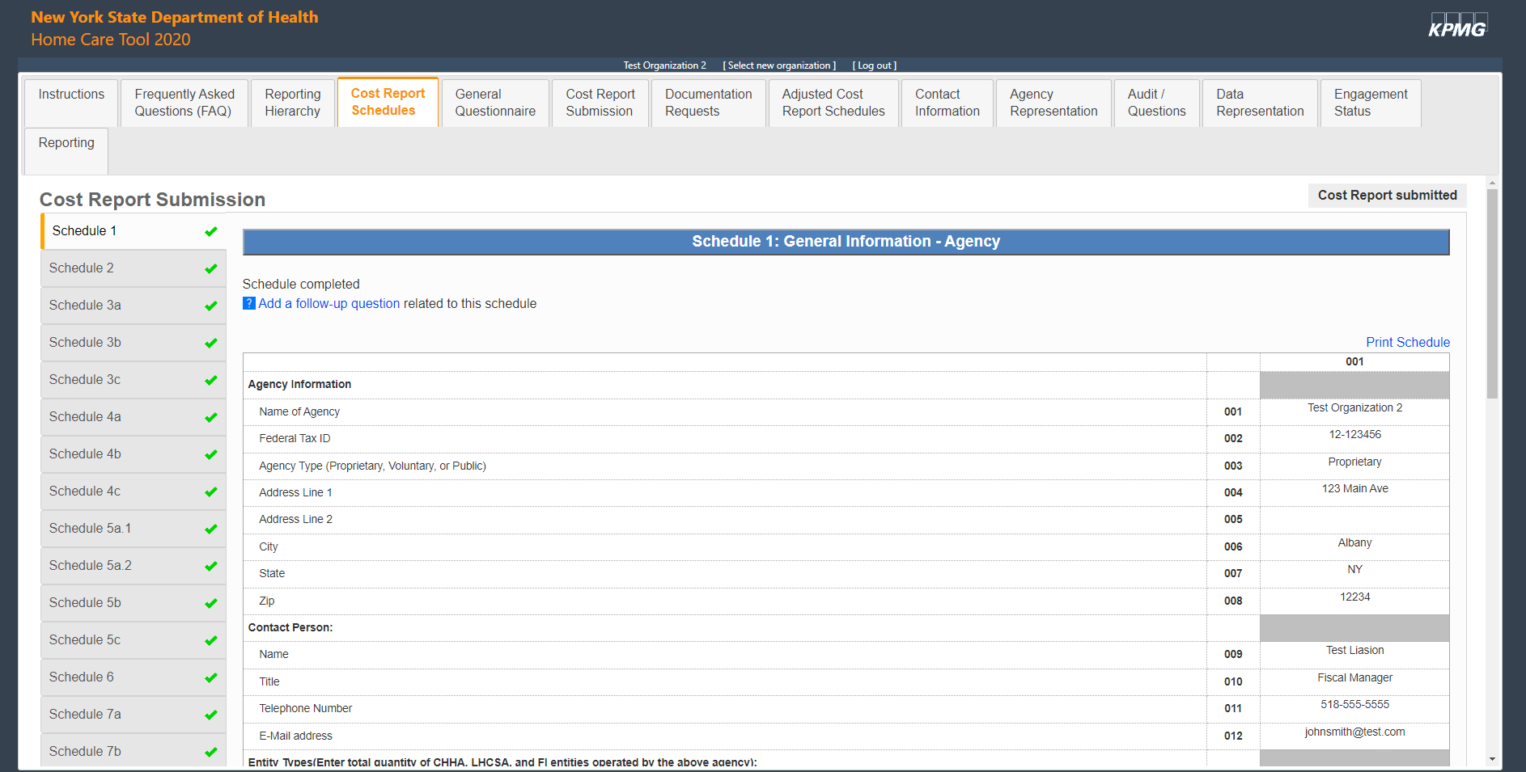

The table below includes the various source documentation required to complete each schedule. <ONLY INCLUDE SCHEDULES YOUR AGENCY GENERATES>
Scheduled to be Completed | Source Documentation <Insert source document as needed for each schedule>
Schedule 1: General Information- Agency | N/A- auto populates from Reporting Hierarchy tab
Schedule 2: General Information- Entity | N/A- auto populates from Reporting Hierarchy tab
Schedule 3a: CHHA Entity Costs & Expenses by Service Type | <e.g., Trial Balance, General Ledger, Audited Financial Statements, statistical reports, payroll register>
Schedule 3b: LHCSA Entity Costs & Expenses by Service Type | <e.g., Trial Balance, General Ledger, Audited Financial Statements, statistical reports, payroll register>
Schedule 3c: FI Entity Costs & Expenses by Service Type | <e.g., Trial Balance, General Ledger, Audited Financial Statements, statistical reports, payroll register>
Schedule 4a: CHHA Entity General Service Cost Centers | <e.g., Trial Balance, General Ledger, Audited Financial Statements, statistical reports, payroll register>
Schedule 4b: LHCSA Entity General Service Cost Centers | <e.g., Trial Balance, General Ledger, Audited Financial Statements, statistical reports, payroll register>
Schedule 4c: FI Entity General Service Cost Centers | <e.g., Trial Balance, General Ledger, Audited Financial Statements, statistical reports, payroll register>
Schedule 5a.1 and 5a.2: CHHA Service Statistics | <e.g., system-generated statistical report>
Schedule 5b: LHCSA Service Statistics | <e.g., system-generated statistical report>
Schedule 5c: FI Service Statistics | <e.g., system-generated statistical report>
Schedule 6: FI Tier Statistics | <e.g., system-generated statistical report>
Schedule 7a: CHHA Current Charge to the General Public | <e.g., chargemaster>
Schedule 7b: LHCSA Current Charge to the General Public | <e.g., chargemaster>
Schedule 7c: FI Current Charge to the General Public | <e.g., chargemaster>
Schedule 8a: CHHA Employee Compensation Analysis | <e.g., Trial Balance, General Ledger, payroll register, employee benefit data, FTE report>
Schedule 8b: LHCSA Employee Compensation Analysis | <e.g., Trial Balance, General Ledger, payroll register, employee benefit data, FTE report>
Schedule 8c: FI Employee Compensation Analysis | <e.g., Trial Balance, General Ledger, payroll register, employee benefit data, FTE report>
Schedule 9a: CHHA Contracted Staff Compensation Analysis | <e.g., Trial Balance, General Ledger, contracted employee data>
Schedule 9b: LHCSA Contracted Staff Compensation Analysis | <e.g., Trial Balance, General Ledger, contracted employee data>
Schedule 10a: CHHA WR&R and Staff Turnover | <e.g., Trial Balance, General Ledger, WR&R cost detail, payroll register, facility onboarding and termination report>
Schedule 10b: LHCSA WR&R and Staff Turnover | <e.g., Trial Balance, General Ledger, WR&R cost detail, payroll register, facility onboarding and termination report>
Schedule 10c: FI WR&R and Staff Turnover | <e.g., Trial Balance, General Ledger, WR&R cost detail, payroll register, facility onboarding and termination report>
Schedule 11a: CHHA Labor Costs | <e.g., Trial Balance, General Ledger, payroll register>
Schedule 11b: LHCSA Labor Costs | <e.g., Trial Balance, General Ledger, payroll register>
Schedule 11c: FI Labor Costs | <e.g., Trial Balance, General Ledger, payroll register>
Schedule 12a: CHHA Labor Utilization | <e.g., Trial Balance, General Ledger, FTE report>
Schedule 12b: LHCSA Labor Utilization | <e.g., Trial Balance, General Ledger, FTE report>
Schedule 12c: FI Labor Utilization | <e.g., Trial Balance, General Ledger, FTE report>
Schedule 13a: CHHA Average Compensation | N/A- this schedule auto-populates
Schedule 13b: LHCSA Average Compensation | N/A- this schedule auto-populates
Schedule 13c: FI Average Compensation | N/A- this schedule auto-populates
Schedule 14a: CHHA Live-In Services | <e.g., census report>
Schedule 14b: LHCSA Live-In Services | <e.g., census report>
Schedule 14c: FI Live-In Services | <e.g., census report>
Schedule 15: Salaried Labor Costs | <e.g., payroll register, FTE report>
Schedule 16: Top 10 Highest Paid Administrative Officials | <e.g., payroll register, FTE report>
Schedule 17: Balance Sheet (Assets) | <e.g., Audited Financial Statements>
Schedule 18: Balance Sheet (Liabilities) | <e.g., Audited Financial Statements>
Schedule 19: Statement of Revenues & Expenses | <e.g., Audited Financial Statements>

The following section details the step-by-step process for completing each schedule. While completing the cost report schedules, please also reference the DOH Home Care Cost Report instructions available on the DOH website.
<ONLY INCLUDE THE SCHEDULES APPLICABLE TO YOUR AGENCY. IF YOUR AGENCY OPERATES A CHHA, THE “A” SCHEDULES WILL BE APPLICABLE. IF YOUR AGENCY OPERATES A LHCSA, THE “B” SCHEDULES WILL BE APPLICABLE. IF YOUR AGENCY OPERATES AN FI, THE “C” SCHEDULES WILL BE APPLICABLE>
- Schedule 3 <insert a, b, and/or c depending on your agency’s entity types>:
- Schedule 3 includes the reporting of the agency’s total expenses, allocated by service type. The “Total Entity Costs” value on Schedule 3 should reconcile to the total expenses per the Audited Financial Statements. Within the supporting documentation for Schedule 3, include a reconciliation from the Schedule 3 “Total Entity Cost” amount to the Audited Financial Statements.
- Note: After completing all the cost report schedules, the “Financial Reconciliation” tab will become available for completion. This tab allows the agency to reconcile the total costs reported on Schedule 3 to the total expenses per the Audited Financial Statements, accounting for any reconciling items. It is strongly encouraged that the Financial Reconciliation tab is completed during the cost report submission period. If <insert agency name> is selected for audit procedures, the Financial Reconciliation tab will be required to be completed.
- <Insert agency-specific process for completing this schedule>
- Schedule 4 <insert a, b, and/or c depending on your agency’s entity types>:
- Schedule 4 includes the reporting of administrative and non-personnel costs allocated by general service cost center. No direct care worker wages and benefits should be included on Schedule 4.
- <Insert agency-specific process for completing this schedule>
- Schedule 5 <insert a, b, and/or c depending on your agency’s entity types>:
- <Insert agency-specific process for completing this schedule>
- Schedule 6: <ONLY APPLICABLE TO FI AGENCIES>
- <Insert agency-specific process for completing this schedule>

- Schedule 7 <insert a, b, and/or c depending on your agency’s entity types>:
- <Insert agency-specific process for completing this schedule>

- Schedules 8 <insert a, b, and/or c depending on your agency’s entity types>:
- <Insert agency-specific process for completing this schedule>

- Schedule 9 <insert a and/or b depending on your agency’s entity types>:
- <Insert agency-specific process for completing this schedule>

- Schedule 10 <insert a and/or b depending on your agency’s entity types>:
- <Insert agency-specific process for completing this schedule>

- Schedule 11 <insert a and/or b depending on your agency’s entity types>:
- <Insert agency-specific process for completing this schedule>

- Schedule 12 <insert a and/or b depending on your agency’s entity types>:
- <Insert agency-specific process for completing this schedule>

- Schedule 13: <insert a, b, and/or c depending on your agency’s entity types>:
- Schedule 13 automatically calculates using the data entered into Schedules 11 and 12. No data entry is required on this schedule.
- Schedule 15:
- <Insert agency-specific process for completing this schedule>
- Schedule 16:
- <Insert agency-specific process for completing this schedule>
- Schedules 17, 18 and 19:
- These schedules are based on the Audited Financial Statements.
- <Insert agency-specific process for completing these schedules>
Additionally, there are a series of questions within each cost report schedule that must be answered, referred to as the “Schedule Specific Questionnaire.” Two of these questions are related to supporting documentation. The first question asks the agency to identify the type of supporting documentation used to complete that particular schedule (check all that apply). The second question asks the agency to add the name of these supporting documents, including the document used to support the allocation methodology used, if applicable. The names entered within this question will flow through to the “Documentation Request” tab.
After each schedule is completed, including the schedule specific questionnaire, select the “mark this schedule as complete” checkbox in the top left corner.

Completing the General Questionnaire tab
The General Questionnaire must be completed before submitting the Home Care Cost Report. The General Questionnaire includes 15 questions related to the agency’s overall processes and procedures. Note that there is no submit button for the General Questionnaire tab; information is automatically saved as it is entered and may be updated at any time until the completed cost report is submitted to DOH and locked.
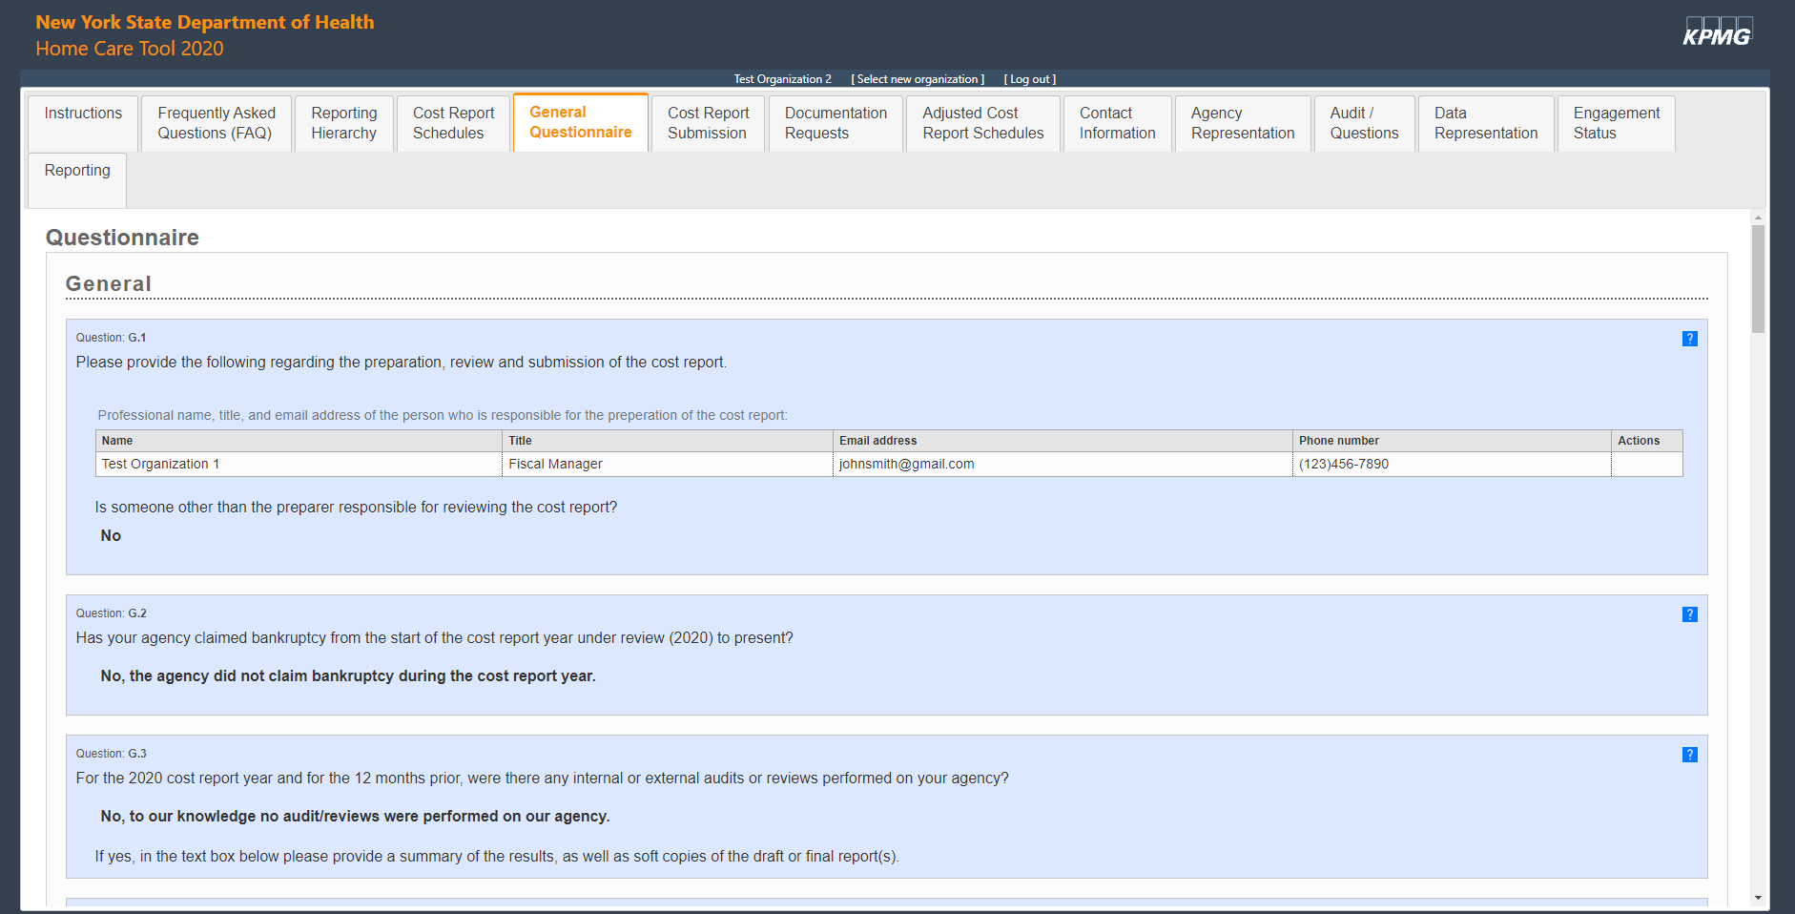

Cost Report Submission
The submission of the Home Care Cost Report occurs within the “Cost Report Submission” tab of the Web-based Tool. To submit the cost report, the cost report schedules and General Questionnaire must be completed. The Department requires that the certification and submission of the Home Care Cost Report come from an officer of the home care agency or a member of the home care agency’s senior management team. It is strongly recommended that this individual be the agency’s CEO, CFO, VP of Finance, or equivalent.
<Insert name of CEO, CFO, VP of Finance, or equivalent and their title> is responsible for certifying and submitting the Home Care Cost Report for <insert agency name>.
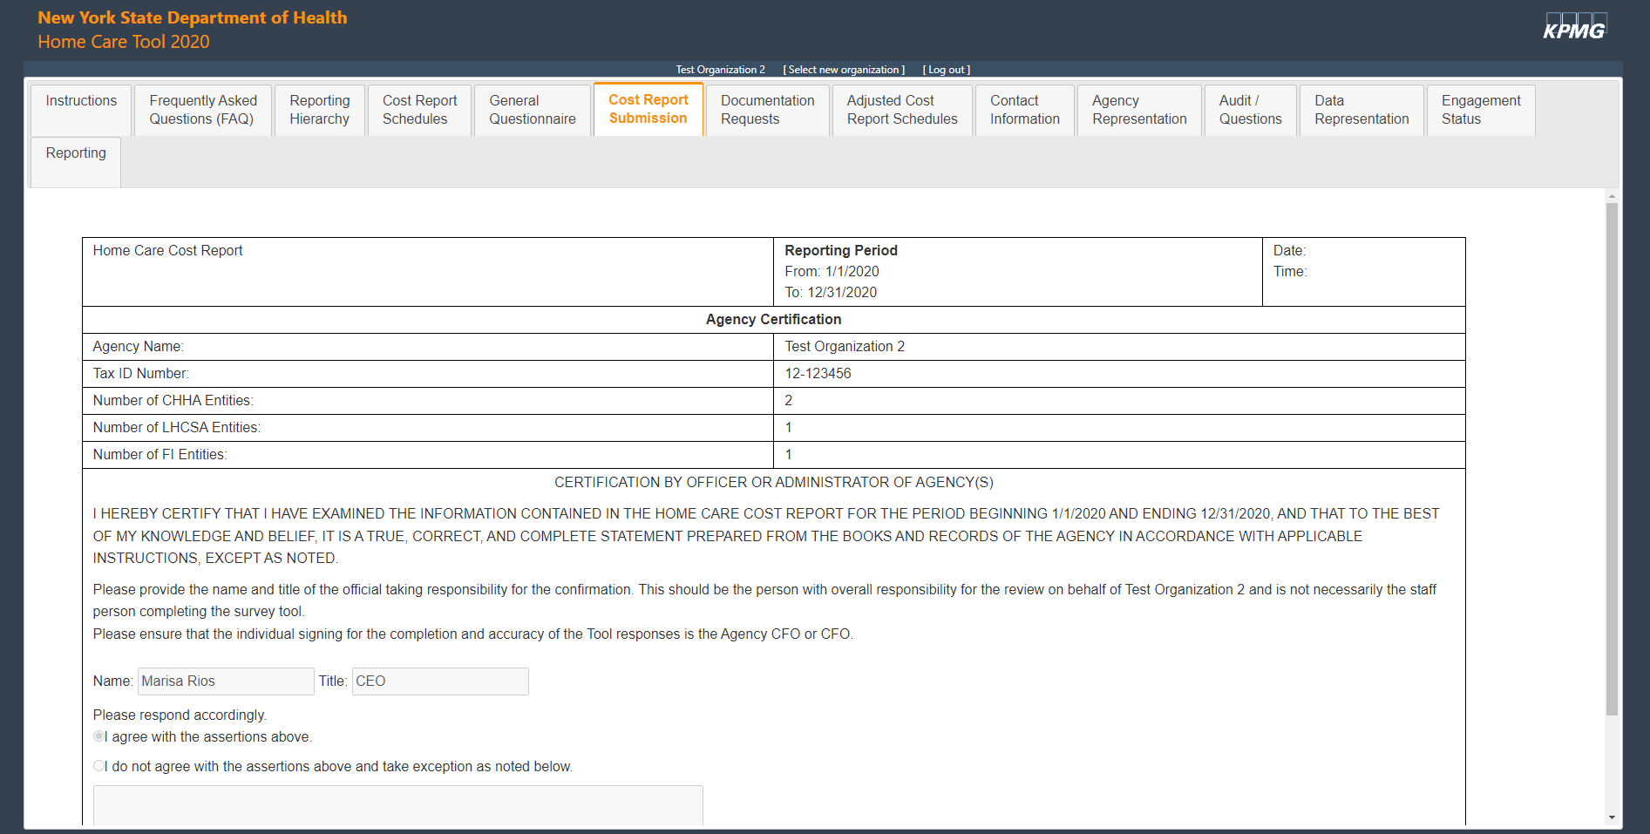

Uploading Supporting Documentation
All supporting documentation must be uploaded via the Secure File Transfer Protocol (SFTP) site within seven calendar days of submitting the cost report. The login credentials for the SFTP site are different than the login credentials for the Web-based Tool. During the cost report submission period, login credentials will be provided for the SFTP site. If you do not receive login credentials for the SFTP site, please reach out to us-advrisknyshc@kpmg.com to request credentials.
Supporting documentation must be uploaded for each cost report schedule. The documents will be deleted from the SFTP site within seven days of being uploaded for information security purposes. Supporting documentation should include:
- Formulas to linked tabs within Excel files
- Underlying calculations for the data, including any reconciliations or crosswalks for information on the cost report that does not tie directly to the supporting documentation
- Credible third-party supporting documentation to validate the cost report and Excel files (e.g., system-generated statistical reports, Audited Financial Statements, etc.)
- A clear allocation methodology crosswalk and explanation that includes specific formulas that were used to arrive at the percentages in the supporting documentation
The supporting documentation names entered in the schedule specific questionnaire will flow through to the “Documentation Requests” tab. After the agency uploads the documentation to the SFTP site, the agency must mark the checkbox in the "Provided" column next to each document name to indicate that the file has been uploaded as shown in the image below.
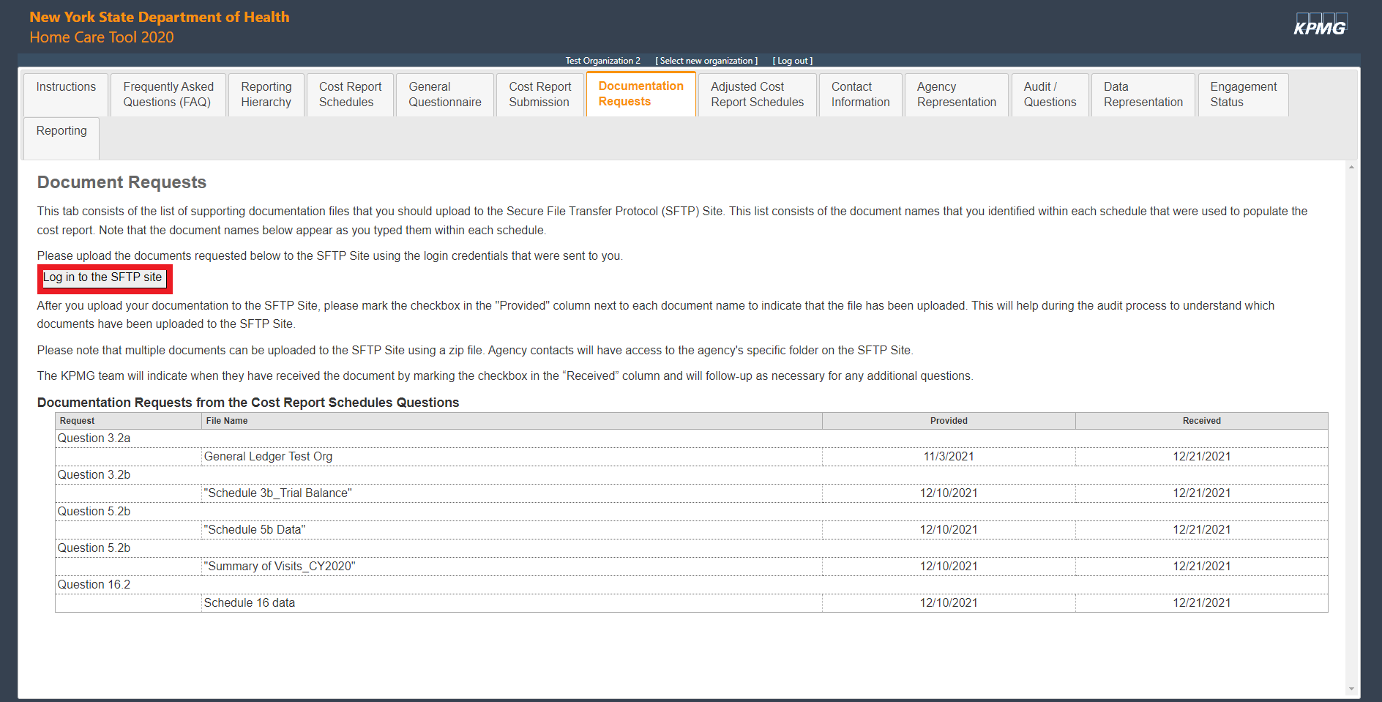

Agency Representation
After the cost report is submitted and supporting documentation is uploaded, the “Agency Representation” tab must be completed. The purpose of this tab is to verify that the information submitted in the cost report and supporting documentation is accurate. Similar to the cost report submission tab, the Department requires that the Agency Representation certification come from an officer of the home care agency or a member of the home care agency’s senior management team. It is strongly recommended that this individual be the agency’s CEO, CFO, VP of Finance, or equivalent
<Insert name of CEO, CFO, VP of Finance, or equivalent and their title> is responsible for completing the Agency Representation tab.
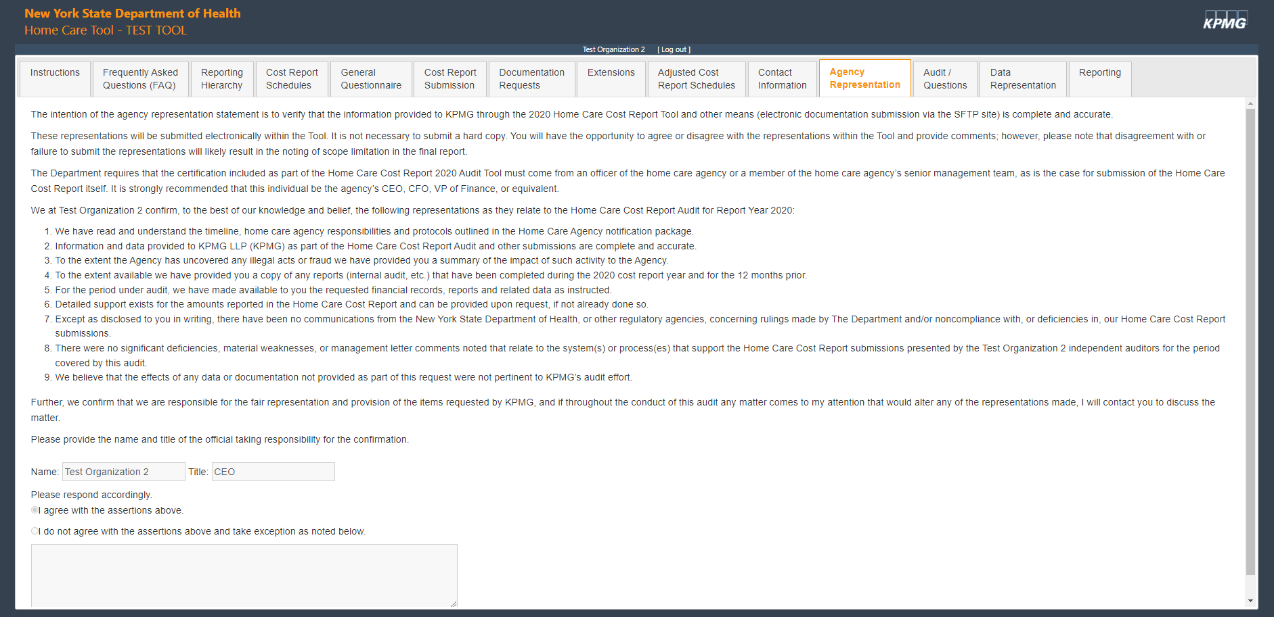

Questions
If there are any questions relating to completing the Cost Report or using the Web-based Tool, you may reach out to US-FM ADV RISK NYS Home Care us-advrisknyshc@kpmg.com.

