NOTE: There are 3 PARTS to the AHHA Training Program Curriculum.
PART 1 describes the Advanced Home Health Aide Law and AHHAs
PART 2 is NCSBN’s “Medication Assistant - Certified (MA-C) Model Curriculum. This curriculum should prepare students to take NCSBN’s Medication Aide Certification Examination.
PART 3 covers injections and injection safety.

PART 1– New York’s Advanced Home Health Aide (AHHA) Law

Part One Learning Objectives:
- The learner will describe the AHHA Law, and the requirements for becoming and working as an AHHA.
- The learner will describe the role of the AHHA and the registered nurse (RN) in providing nursing care (including performing advanced tasks and documenting care) for a patient.

I. New York's Advanced Home Health Aide Law

In 2016, New York’s Advanced Home Health Aide Law (Chapter 471 of the Laws of 2016) was enacted. The Law allows RNs to assign advanced home health aides (AHHAs) to perform nursing tasks (known as "advanced tasks') for certain hospice and home care patients. This law requires AHHAs to perform these assigned advanced tasks under the direct supervision of an RN. It also requires the AHHA and RN to work for a hospice program, licensed home care services agency (LHCSA), certified home health agency (CHHA), long term home health care program (LTHHCP) or enhanced assisted living residence and provide care to their employer’s home care or hospice patients at home.

What is an Advanced Home Health Aide or “AHHA”?

An "AHHA" is a certified home health aide with home care experience and who has completed an AHHA training course and other legal requirements to qualify to perform advanced tasks and is listed in the New York State Department of Health’s home care worker registry as an advanced home health aide.

- An AHHA is not a nurse.
- An AHHA cannot accept employment as an LPN or as person licensed to practice nursing in New York.

An AHHA performs assigned advanced tasks for certain hospice and home care patients under the direct supervision of an RN. An AHHA can also provide home health aide services to these patients. An RN must assign the advanced tasks to the AHHA in writing. The AHHA and RN must work for the same licensed or certified home care agency, hospice program, or enhanced assisted living residence.

What are Advanced Tasks?

“Advanced Tasks” are some (but by no means all) nursing care tasks commonly performed by LPNs in long term care and home care settings. Examples include:

- The administration of medications that are routinely taken by a medically stable patient and relatively easy to administer to the patient. These medications can be administered by the following routes only:

  - (a) oral;
  - (b) sublingual (under the tongue);
  - (c) buccal (in the cheek);
  - (d) ophthalmic (eye);
  - (e) otic (in the ear);
  - (f) nasal;
  - (g) rectal;
  - (h) vaginal;
  - (I) topical; or,
  - (j) inhaled through the nose or mouth.

- In addition, some medications may be injected (see below).

  - Subcutaneous or intramuscular injections of low molecular weight heparin or medication prescribed to treat diabetes and the use of a prefilled auto-injector of naloxone or epinephrine in an emergency.

Advanced tasks DO NOT include:

- Tasks requiring an AHHA to convert or calculate the dose of any medication or to determine a patient’s need for medications (including PRN medications);
- Tasks requiring medication to be administered through enteral feeding tubes such as gastrostomy or nasogastric tubes;
- Tasks involving the use of intravenous or subcutaneous infusion devices on a patient;
- Tasks involving the use of a mechanical ventilator on a patient;
- Tasks involving sterile or aseptic technique, except for the administration of injections identified above;
- Tasks involving professional nursing judgement, observation, monitoring or assessment of a client; or
- Tasks that are outside the scope of practice of an LPN.

II. Steps for Becoming an AHHA

Step 1: An individual must first meet the following requirements:

- Be 18 or older;
- Have a high school diploma, GED or similar education credential;
- Be able to read, speak and write English and have basic math skills;
- Be a certified Home Health Aide and currently listed on the New York State Home Care Worker Registry as such;
- Have at least 1 year of experience working as a certified home health aide or a certified personal care aide;
- Be CPR or BCLS certified by the Red Cross, the American Heart Association or another organization.

Step 2: After meeting all requirements in Step 1, the individual must enroll in and graduate from a New York State approved Advanced Home Health Aide Training Program.

Step 3: After completing the approved AHHA training program, the candidate must take and pass the New York Medication Aide Certification Examination® (MACE®).

After the candidate has passed the New York Medication Aide Certification Examination® (MACE®) and New York State verifies that they have met all other legal requirements to be certified as AHHA, the individual will be added to the New York State Home Care Worker Registry as an Advanced Home Health Aide (AHHA). In addition, the Advanced Home Health Aide Training Program will issue the individual an Advanced Home Health Aide certificate.

III. KEY Requirements for Working as an AHHA.

An AHHA can perform advanced tasks for a home care patient if:

- The AHHA is an employee of an organization that is licensed by the Department of Health to operate a hospice program, enhanced assisted living residence, licensed home care services agency (LHCSA), certified home health agency (CHHA), or long-term home health care program (LTHHCP) and is approved to provide advanced home health aide services. The AHHA can only perform advanced tasks for their employer’s patients where the patient resides.

Note: AHHAs are not allowed to perform advanced tasks as an “independent contractor”, or while employed by a nursing home, hospital, clinic or other organization.

- A RN who works for the same employer as the AHHA is responsible for assigning the AHHA to the advanced tasks for the patient. Before assigning an AHHA to perform an advanced task for a patient, the RN must provide the AHHA with training on performing the advanced task appropriately for the patient. The RN must also provide the AHHA with written instructions on how to perform the advanced task.

- The patient, (or a person who can consent to care for the patient) must consent to the assignment of advanced tasks.

- The AHHA must consent to the assignment. The AHHA should consent only if they understands the assignment and reasonably believes they can perform the assigned advanced task safely and competently.

IV. The Assignment of Advanced Tasks: RN’s role and AHHA’s role

RN’s Role: A RN may assign an AHHA to perform one or more advanced tasks for a home care or hospice patient. The term "assignment" in this context means that an RN “delegates: or gives to an AHHA a specific advanced task to do for a specific patient and this task is described in writing.

Before assigning an AHHA to perform an advanced task, the RN must do the following:

- Complete a nursing assessment of the patient to determine the patient’s health status and care needs and determine that the patient’s health status is stable and predictable.

- Ensure that the advanced task to be assigned is consistent with a physician's, nurse practitioner's or prescriber's ordered care.

- Ensure that the patient (or when the patient lacks capacity to consent, a person who can consent for the patient) has consented to the assignment of advanced task(s) to the AHHA.

- Provide case specific training to the AHHA on how to perform the advanced task(s) to be assigned.

- Verify that the AHHA can safely and competently perform the advanced task(s) for the patient; understand the patient’s current needs; and, can communicate effectively with the patient.

- Provide to the AHHA written, patient specific instructions for performing the advanced task and criteria for identifying, reporting and responding to problems, errors or complications.

AHHA’s Role: The AHHA must agree to perform the advanced task to be assigned. The AHHA should not agree to an assignment unless the AHHA understands the assignment and reasonably believes they can perform the assigned advanced task safely and competently.

Note: An AHHA is not allowed to modify an assignment or assign or reassign advanced tasks to other persons.

The RN must document the assignment advanced task(s) to the AHHA as well as document any modification or termination of an assignment in the patient’s individualized service or care plan or health record.

V. The RN’s Role in Providing Direct Supervision of AHHAs

A RN must provide direct supervision when an AHHA performs assigned advanced tasks. "Direct supervision" means the provision by a supervising RN of training, guidance, direction and oversight relating to the performance of advanced tasks by an AHHA. Such direct supervision shall be determined by the RN, based on the complexity of such advanced tasks, the skill and experience of the AHHA assigned to perform the advances tasks, and the health status of the client for whom the advanced tasks are being performed. The RN who provides the direct supervision to an AHHA must meet the following requirements:

- Be knowledgeable of the patient’s current health status, nursing care needs and the patient’s home care plan or plan of services.

- Be able to assign, rescind or modify advanced tasks assigned to an AHHA.

- Be continuously available to speak with the AHHA by phone or other means. If the RN is not working in the same location as the AHHA.

- Must personally visit a patient or arrange for another qualified licensed health professional to visit the patient whenever necessary to protect the health and safety of the patient.

- Must perform an initial and thereafter regular and ongoing assessment of the patient's needs.

- Conduct an in-home visit to the patient at least every two weeks to observe and oversee (supervise) services provided by the AHHA.

VI. The AHHA’s Role in Performing Advanced Tasks

Accepting an Assignment to perform Advanced tasks.

With a new patient, before accepting an assignment, the RN and the AHHA should meet to discuss the service to be performed for the patient. The RN must specify the specific tasks to be performed by the AHHA.

At the beginning of each shift and before starting patient care, the AHHA must know the name of the RN assigned to supervise the AHHA. If the RN is not working on the same premises as the AHHA, the AHHA must have a phone number or other information or technology needed for promptly contacting the supervising RN.

The AHHA may perform advanced tasks for a home care or hospice patient that an RN has assigned to the AHHA in writing.

When performing the advanced tasks, the AHHA must follow the written instructions from an assigning or supervising RN pertaining to the performance of advanced tasks.

The AHHA shall not perform an advanced task if the patient refuses the care, or if the patient lacks capacity to consent, a person authorized by law to consent for the patient, refuses the care.

The AHHA must promptly notify the supervising RN if at any time an AHHA reasonably determines the following:

- They are unable to safely perform an advanced task as assigned; or

- There are any problems or issues with providing care as assigned; or

- The patient's health condition deteriorates or changes,

The AHHA must document the performance or nonperformance of each assigned advanced task in the patient’s care or service plan or health record.

End of PART 1

Estimated class time 3 hours.
No practice, laboratory or clinical required for Module 1
AHHA Training Program Curriculum

PART 2 - NCSBN Medication Assistant-Certified (MA-C) Model Curriculum

_________________________________________________________________________

PART 3: Injections and Injection Safety

PART 3 Learning Objectives:

- The learner will describe what a “prefilled” syringe is and the 3 parts of a syringe.
- The learner will describe how to give a subcutaneous injection.
- The learner will describe how to give an intramuscular injection.
- The learner will describe what the following types of drugs are used for: low molecular weight heparin, insulin, epinephrine, naloxone, and glucagon.
- The learner will describe infection control and injection safety measures when giving injections.
- The learner will demonstrate giving subcutaneous and intramuscular injections, and documenting the administration of the injection in a patient’s medication administration record (MAR).

I. Introduction

- Overview

Part 3 covers the following types of injections that an AHHA can give:

- Subcutaneous injections (using a prefilled syringe and needle) of low molecular weight heparin and diabetes medications.

- Intramuscular injections (using a prefilled syringe and needle or an autoinjector) of Glucagon, Epinephrine, or Naloxone in an emergency.

A prefilled syringe contains the exact dose of the prescribed drug to be administered by injection.

Part 3 describes the process for giving “prefilled” injections subcutaneously and intramuscularly as well as relevant injection safety and infection control measures. Finally, Part 3 requires each student to practice giving injections.

- Prefilled syringes and needles and autoinjectors

A syringe and needle or an autoinjector are often used to give subcutaneous and intramuscular injections. There are several types of syringes and needles. All syringes have a barrel (the part of the syringe that holds the medication), a plunger (part of the syringe within the barrel that moves back and forth to withdraw or instill medication and a tip (the part of the syringe to which a needle is attached). Syringes usually are calibrated in milliliters (ml), cubic centimeters (cc) or units (U). A “pre-filled” syringe contains the correct dose of a prescribed medication in the barrel. Needles are supplied in various lengths and widths, are hollow and very sharp at one end. Needles come with caps that are removed when it is time to give an injection.

Diagram of Needle and Syringe used for Subcutaneous Injections

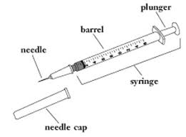

Note: The needle is short and thin. It comes with a needle cap to cover and protect it before it is used.
The barrel holds the medication to be injected. It is marked with lines that show you how much medicine is in the syringe. Syringes usually are calibrated in milliliters (mL), cubic centimeters (cc) or units (U).
The plunger is the long thin rod that slides up and down inside the barrel. It is used to push the medicine out of the barrel through the needle.
Syringes are meant for one-time use. Once used, they should be thrown away in special puncture proof containers.

An “auto injector” is used to give an injection of a single dose of a (usually a life-saving) drug. Auto injectors are designed to be easy to use and are intended for self-administration by patients or administration by untrained or minimally trained personnel.

AUTOINJECTOR DIAGRAM

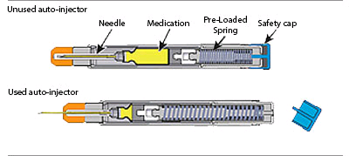

II. Infection Control and Injection Safety

An AHHA must practice good infection control and injection safety to prevent the spread of harmful microorganisms (germs) to a patient and to himself or herself. An AHHA must perform the following infection control and safety measures when giving injections:

- Handwashing
- Use Clean Gloves Appropriately
- Check Medications for Possible Contamination.
- Use sterile techniques when giving injections.
- Properly dispose of needles, syringes and other items (gloves, alcohol swabs, etc.).
- Avoid needle stick Injuries.
- USE A NEEDLE & SYRINGE or AUTOINJECTOR ONLY ONCE! An AHHA must never reuse needles, syringes or autoinjectors (even on the same patient).
- Never attempt to recap needles once the injection is given when a sharps container is available.

Hand Washing
AHHAs must practice good hand hygiene to protect their patients and themselves from harmful germs. AHHAs must perform hand hygiene:

- Whenever their hands are visibly soiled;
- After barehanded touching of items with blood or body secretions on them;
- Before and after treating each patient; and,
- Before putting gloves on and again immediately after removing gloves.

AHHAs must wash their hands with soap and water whenever their hands are visibly dirty or soiled. AHHAs may use alcohol based hand rub or hand wipe to wash their hands only if their hands are NOT visibly dirty or soiled.

Appropriate Use of Clean Gloves

In addition to hand washing, AHHAs must wear clean gloves in situations involving possible contact with a patient’s blood or body fluids or non-intact skin, and giving injections.

*The use of gloves DOES NOT decrease the need for hand washing! To avoid spreading harmful germs AHHAs must:

- NOT wear the same pair of gloves for the care of more than one patient.
- NOT wash gloves. Gloves cannot be reused.
- Change gloves and wash their hands anytime gloves get visibly dirty, contaminated or soiled.
- NOT their wash hands with gloves on and continue providing care.
- Remove gloves immediately after finishing a task, without contaminating themselves or other items with germs.

Procedure for donning and removing gloves:

- Wash hands before putting on gloves
- Select proper size of gloves
- Put on gloves
- Perform medication administration task and dispose of needle and syringe
- Remove gloves immediately without contaminating self.
- Grab the glove on the non-dominant hand at the palm with the other gloved hand.
- Pull the glove off the nondominant hand and crumble it up into the other gloved hand.
- Using skin against skin, run finger of non-dominant hand inside glove at wrist and slide
off, trapping the crumbled up glove in the second glove.
- Throw away gloves per employer policy.
- Wash hands.

Checking medications for possible contamination

An AHHA must check the expiration date on any medication to be injected. If the medication has expired or has no expiration date, the AHHA should not administer the medication and must contact the supervising nurse for further instructions. An AHHA must look at the medication in the syringe. If it is cloudy (when it should be clear) or is a different color, the AHHA must contact the supervising nurse for further instructions because the medication may be contaminated. Do not administer the medication.

Using sterile techniques when giving injections

Needles and syringes and autoinjectors MUST remain completely sterile (germ free) until after they are used for an injection. Using sterile technique helps to keep an area or an object free of microorganisms (germs). AHHAs use sterile technique to avoid contaminating the needle or syringe before giving an injection. When giving injections, AHHAs:

- Must disinfect the injection site with an antiseptic or alcohol swab before giving an injection.

- Must NOT allow any unsterile object to touch the following parts of the syringe before giving an injection: the tip of the syringe, inside the barrel of a syringe, the shaft of the plunger.

- Must NOT allow any unsterile object to touch the shaft or tip of the needle before it is injected into the patient.

- Stop the task if the needle becomes contaminated.

- Discard the needle/syringe and call the supervising nurse for further instructions.

Proper disposal of needles, syringes, gloves and other supplies

AHHAs should consider all needles, syringes and autoinjectors used on a patient to be contaminated with potentially infectious germs. All used syringes and needles (even syringes with retractable needles) must be disposed of properly. After giving an injection, the needle should be left uncapped and deposited in the nearest biohazard container (if one is available).

Avoiding needle stick injuries

If an AHHA uses a needle and syringe or an autoinjector without a retractable needle, there are two techniques for avoiding needle stick injuries. After giving an injection, the needle should be left uncapped and promptly deposited in the nearest puncture resistant container (if one is available). If not, then the protective cap covering a needle can be replaced by using the “one handed scoop technique” (threading the needle into the cap without touching the cap itself). An AHHA should never attempt to bend or break used needles. IMPORTANT. The “one handed scoop technique” is used ONLY when a sharps container is not available.

If an accidental needle stick injury occurs involved a used needle, the AHHA should:
- Wash the area with soap and water.
- Immediately report the injury to the supervising RN.
- Document the injury.
- Obtain medical follow up as soon as possible to receive timely and appropriate post-exposure prophylactic treatments as well as counseling on the potential for infection.

The Nurse Instructor must use performance evaluation skills checklist. Each student must demonstrate: proper hand hygiene, donning and removing gloves. The student must be able to identify the three parts of a syringe and the calibration marks. The student must be able to identify an insulin syringe. The student must identify the parts of the needle and syringe that must remain sterile.

III. Subcutaneous Injections

An AHHA is allowed (in some circumstances) to give subcutaneous injections of low molecular weight heparin and drugs that treat diabetes using a “prefilled” syringe and needle. A subcutaneous injection is a method of giving a small amount of medication into a patient’s subcutaneous tissue layer between the skin and the muscle. Subcutaneous injections are typically given in the upper arm, thigh, or abdomen.

DIAGRAM OF SUBCUTANEOUS INJECTION

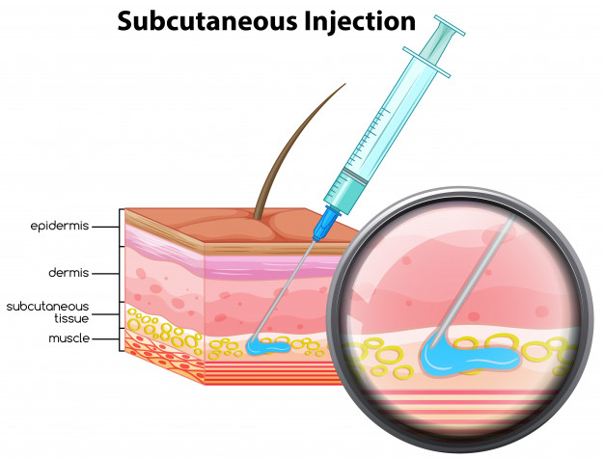

There are two of types of prefilled syringes that an AHHA may use for subcutaneous injections:

- A drug manufacturer prefilled syringe, which includes the exact dose and drug prescribed for the patient. These syringes and needles are labeled or are in packages that are labeled with the patient’s name, drug, dose, and expiration date.

- The supervising RN may prepare a pre-filled syringe of the exact dose and drug prescribed for the patient. The RN is responsible for ensuring that the syringe is appropriately stored and labeled for future administration to a specific patient by the AHHA.

- Low Molecular Weight Heparin (LMWH)

Low Molecular Weight Heparin (LMWH) is a type of anticoagulant drug. These anticoagulant drugs prevent harmful blood clots from forming inside a patient’s body, especially in leg veins and lung veins. Subcutaneous injections of a LMWH drug may be prescribed for home care patients who are at increased risk for harmful blood clot formation due to recent surgery, illness or other reasons. Some patients may need daily subcutaneous injections of a LMWH for long periods of time. Generic names of LMWH drugs include: Enoxaparin and Dalteparin. If these drugs come with the safety shield (retractable needle) this safety mechanism should be utilized. After the injection is given, and away from the patient, put pressure on the plunger. The needle will retract back inside the syringe portion. This device will still need to be placed into a sharps container.

**Helpful hint: Hold the syringe in your writing hand like a pencil for better control when giving the injection. Enoxaparin should be given two inches from the umbilicus (belly button) and rotate sites as instructed.

- Injectable Diabetes Drugs

Diabetes is a disease associated with abnormally high levels of sugar (glucose) in the blood. Physicians and nurse practitioners may prescribe subcutaneous injections of drugs to lower or control blood sugar in some diabetic patients. Some diabetic patients need one or more subcutaneous injections of diabetes drugs every day. There are insulin and non-insulin injectable medications that are prescribed to treat diabetes. There are many types of insulin drugs, including:

- Rapid-acting insulin drugs, such as Humalog (Lispro), Novolog (Aspart), and Glulisine (Apidra).
- Short-acting insulin drugs, such as Regular Insulin (Humulin R, Novolin R).
- Intermediate acting insulin drugs such as NPH insulin (Humulin N) and Detemir (Levemir).
- Long-acting insulin drugs, such as Glargine (Lantus).

DIAGRAM OF INSULIN INJECTION SITES

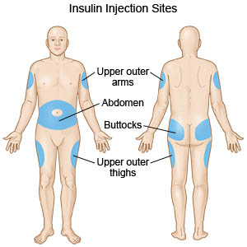

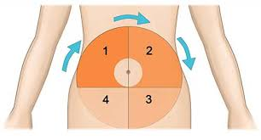

- Giving Subcutaneous Injections of a Low Molecular Weight Heparin (LMWH) or Diabetes Drug with a Pre-Filled Syringe and Attached Needle

Supervising RN’s Role

A supervising RN must provide case-specific training to the AHHA before assigning the AHHA to give subcutaneous injections of LMWH or a diabetes drug to a patient using a “prefilled” syringe. The assignment is must be documented as a nursing directive (written instructions for giving the injection to the patient). The RN must verify that all syringes to be used by the AHHA are prefilled with exact dose of the prescribed drug to be administered, and that the needle attached to the syringe is appropriate for subcutaneous injections. The RN must also ensure that prefilled syringe and needle are stored appropriately and labeled appropriately or in an appropriately labeled container.

AHHA’s Role

The AHHA reviews the written assignment known as the nursing directive that specifically relates to the injection to be given and the medication administration record (MAR). The nursing directive and the MAR provide information and instructions for administering the injection, such as the drug name, dose, route of administration, and when to give the drug.

The AHHA verifies the six (6) rights of medication administration:

- The right patient
- The right medication
- The right dose
- The right time
- The right route and,
- The right documentation

The AHHA must follow the instructions in the nursing directives for giving the injection. The AHHA must contact the supervising RN with any questions or concerns.

Important steps for giving a subcutaneous injection are described below. A nursing directive may have different steps for an AHHA to follow when giving an injection.

- Review written directive for giving injection and the MAR.
- Retrieve prefilled syringe.
- Verify the six rights of medication administration: the right patient and MAR, right medication, right dose right time and route and right documentation.
- Assemble alcohol or antiseptic wipes, Sterile 2” x 2” gauze pads, surgical tape.
- Wash hands.
- Explain the procedure to the patient and assist the patient with positioning for the injection.
- Don gloves.
- Select injection site.
- The nursing directive and/or employer policy and procedure must include guidance on finding an appropriate injection site (usually on the upper arm thigh, abdomen or back) and ensure that the injection site is rotated with each injection.
- The injection site should be free of scars hair lesions bruises swelling and skin irritation.
- Using an alcohol wipe or other disinfecting wipe, swab the selected injection site.
- Remove the cap from the needle on the pre-filled syringe, being careful not to touch the needle.
- Pinch up the skin at the injection site, and, using a dart fashion, insert needle directly through the skin, at a 45°-90° angle. For an obese patient, use a 90° angle.
- Push the syringe plunger and inject the complete volume of drug contained in the syringe.
- Some syringes have needles that will retract into the syringe once all the drug is injected. If the syringe does not have a retractable needle, withdraw the needle gently at the same angle at which it entered.
- As soon as the needle is withdrawn, release the skin.
- Swab the injection site, using an alcohol wipe and the 2” by 2” gauze pad if there is any blood draining from the injection site.
- Dispose of syringe and needles. Remove and dispose of gloves.
- Wash hands.
- Document the administration of the medication in the MAR.

**If the patient refuses to take the medication, then the AHHA should note this in the MAR and contact the supervising RN or take other action pursuant to the nursing directive.

IV. Intramuscular (IM) injections

An intramuscular injection or “IM injection” is a method giving a small amount of medication into a patient’s muscle tissue. During an IM injection, the needle is inserted through the patient’s skin and subcutaneous fat layer and into the muscle tissue (usually in the upper arm, thigh or buttocks). AHHA can give (in some circumstances) intramuscular injections of Glucagon, Epinephrine, or Naloxone in an emergency using a “prefilled” syringe and needle or autoinjector. These prefilled syringes autoinjectors usually come in “emergency kits” that also include instructions on how to give the injection in an emergency.

***AHHAs must call 911 and the supervising RN.

DIAGRAM OF INTRAMUSCULAR INJECTION

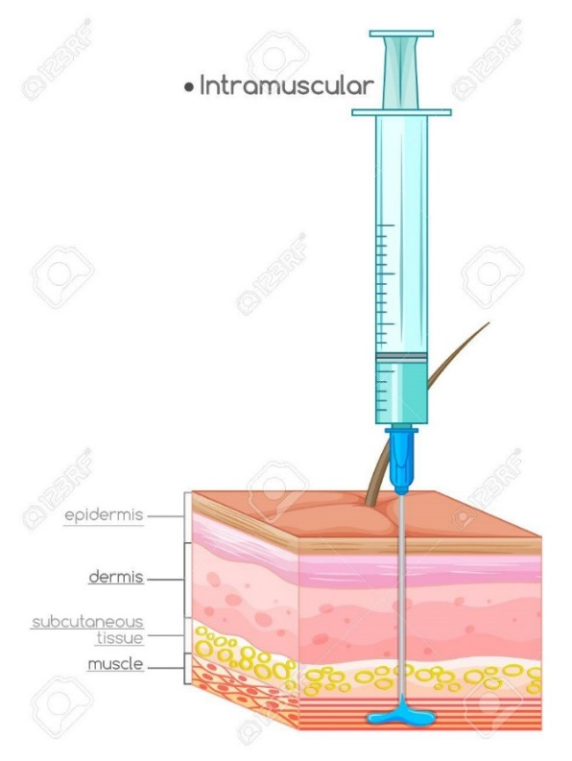
Glucagon

Glucagon is a drug that is given for the emergency treatment of severe low blood sugar (hypoglycemia) in a person with diabetes. Glucagon works by making the body release sugar (glucose) into the blood stream to bring the blood sugar level back up. Sometimes when a person misses a meal or does not eat enough food for the insulin taken, or exercises too much for the amount of food eaten, the person’s blood sugar becomes too low. If not treated quickly, mild or moderate low blood sugar can become severe. Persons with severe low blood sugar may be unable to eat or drink or may be unconscious. Since some persons with diabetes can experience severe low blood sugar almost anywhere, they carry a glucagon injection kit with them. The kit usually includes a syringe prefilled with liquid and a vial of glucagon powder. The kit often includes written instructions on how to add the glucagon powder the liquid in the vial to make the injectable solution as well as instruction on how to give the Glucagon injection. There are several glucagon kits commercially available, including: Glucaton, GlucaGen Diagnostic Kit. Glucagon can be injected into the arm, thigh or buttocks.

Naloxone

Naloxone a drug that is given for the emergency treatment of a narcotics (opioid) overdose. Opioids are powerful drugs such as morphine or heroin. Opioid overdoses suppress breathing, which may ultimately lead to death. In an emergency, an AHHA can give naloxone nasally (which is not covered in this module) or by intramuscular injection (which is). If Naloxone is given by IM injection into the muscle of the arm, thigh or buttock, it may reverse most effects of opioids within 2-5 minutes. Naloxone is usually supplied in kits that include directions for administering the IM injection.
Epinephrine

Epinephrine is a drug that is given for emergency treatment of severe, potentially life-threatening allergic reactions known as anaphylaxis. Anaphylaxis can occur within minutes after a person is exposed to something that he or she is allergic to, such as, venom from bee stings, peanuts, penicillin or latex. Physicians, nurse practitioners and physician assistants often prescribe EPI-Pen kits for their patients with life threatening allergies. The kit includes an auto-injector (usually called an “Epi-pen”) which is prefilled with a dose of epinephrine that can be given via an intramuscular injection for the emergency treatment of anaphylaxis. The kit also includes instructions on how to give the injection. Persons with life threatening allergies should always have an Epi-Pen Kit available or available to their caregivers to be used in an emergency, if needed.

Giving an Emergency Intramuscular injection of Epinephrine using an EPI-Pen Kit

Supervising RN’s Role

A supervising RN trains an AHHA on how to administer the EPI-pen injection to the patient before assigning the AHHA to give the injections using an EPI-Pen Kit in writing. The assignment is usually documented as a nursing directive. The RN is also responsible for verifying that all EPI Pen kits to be used by the AHHA is complete, not expired and labeled appropriately.

AHHA’s Role

The AHHA must already be familiar with the nursing directive (written assignment) that specifically relates to the EPI-pen injection including with the signs and symptoms of anaphylaxis as described in the written directive. The nursing directive includes instructions for administering the injection, such as the drug name, dose, route of administration, and when to give the drug. The AHHA must follow the instructions in the nursing directives for giving the injection and the AHHA must call 911 immediately.
Here is an example of steps for using an EPI Pen in an emergency. A nursing directive may have different steps for an AHHA to follow when giving an injection.

- Open the emergency kit that contains the autoinjector prefilled with the medication to be administered intramuscularly.
- Don clean gloves, if immediately available.
- Follow instructions in the Epi pen kit on giving the injection. The instructions will provide information, such as: Form a fist around the EPI pen the black tip pointing down. With the free hand, pull off the gray activation cap. Jab the EPI pen firmly into the outer thigh, at an angle perpendicular to the thigh (90°), and hold it there for 10 seconds. (The injection may be made directly through clothing). Remove the unit and massage the area for 10 seconds to make sure the medication is absorbed. Ensure the injection was successful: examine the used Epi-Pen, if the needle is projecting through the black tip, the injection was a success.
- Call 911 immediately!!!

Each student should practice giving an intramuscular injection to a patient or in a simulation lab and be evaluated using the performance skill check list.

Diagram of Potential Site for Giving an IM Injection
